Punjab Skill Development Mission (PSDM)

EXPRESSION OF INTEREST
(EOI)

EOI NO.
PSDM/ETP/2017-18/02
DATE………..

Empanelment of Training Partners to undertake projects for various Skill Development Schemes under Punjab Skill Development Mission

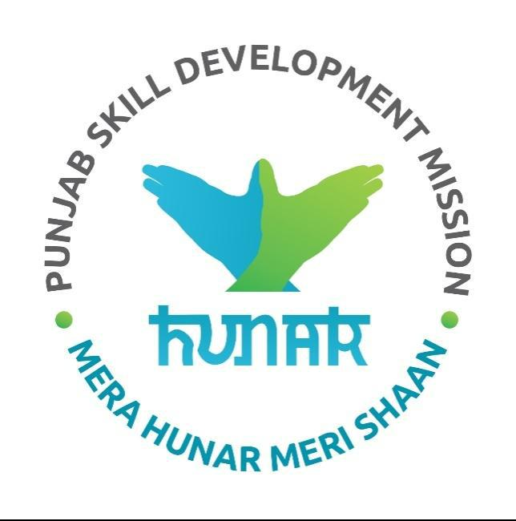

Punjab Skill Development Mission SCO No. 149-152, 2nd Floor, Sector 17 C, Chandigarh Tel. 0172-2720152, 2720153

EOI for Empanelment of New Training Partners 2.0 Page 1 of 6

Punjab Skill Development Mission (PSDM)

Index

Sr. No. | Particulars | Page No.
1 | Introduction | 3
2 | Eligibility Criteria | 3
3 | Tender Cost & Proposal Processing Fees (Non-Refundable) | 4
4 | Indicative Timelines | 4
5 | Duration of Empanelment | 4
6 | Cost Norms | 5
7 | Training Infrastructure | 5
8 | Employability Potential Assessment | 5
9 | Selection Process | 5
10 | Evaluation Criteria | 5
11 | Submission of Proposal | 6

EOI for Empanelment of New Training Partners 2.0 Page 2 of 6

Punjab Skill Development Mission (PSDM)

- Introduction

The Government of Punjab accords highest priority to the Skill Development of its youth and to make them employable. The State Government accordingly has set up Punjab Skill Development Mission (PSDM) in line with the National Skill Development Policy. The Mission would be a single point within the Government to formulate and steer various skill development schemes.

Currently the Mission is implementing the following schemes and projects:

- ESTP Component of NULM (A skill training program for urban youth) http://nulm.gov.in/

- BOCW (A skill training program for wards & dependents of construction workers) http://bocw.punjab.gov.in/

- DDU-GKY (A skill training program for rural youth) http://ddugky.gov.in/

- PMKVY -2.0 (A skill training program for urban &rural youth) http://pmkvyofficial.org/
- Corporate Social Responsibility (CSR) Projects
- Special Projects: The Special Projects shall include:-

  - Skill Training in Traditional Crafts such as Terracotta, Phulkari, Wood Inlay, Crochet, Fabric Printing, Punjab Jutti, Dari/Khes, Basketry, Artificial Jewellary, Hand Painting, Jute and Best Out of Waste.

  - Skill Training targeted for specific segment of the society such as Border Area Residents and Persons with Disabilities (PWD).
  - Skill Training for Entrepreneurship Development and Self Employment.

PSDM invites the Expression of Interest (EOI) in categories A & B as listed below, who are interested and eligible for submission of proposal for empanelment to undertake projects under above mentioned skill training schemes in the State of Punjab. In case PSDM runs any other scheme, the Training Partners may be considered for the same.

The training partners must apprise themselves with all aspects of the detailed guidelines of the schemes mentioned above before applying.

- Eligibility Criteria

The Training Partners will be empanelled with PSDM under the following two categories:

Category A – Agencies having Skill Training Experience

This category is applicable to agencies which have prior experience in implementation of Government Sponsored (Central/State) Skill Training Schemes in India.

Category B – Agencies having no Prior Skill Training Experience

This category is applicable to agencies which don’t have prior experience in implementation of Government Sponsored (Central/State) Skill Training Schemes in India.

All the agencies mentioned above should:
- Be a registered legal entity

- Apply under only one category mentioned above,
- Will not involve into franchising/subletting/outsourcing of any activity related to training,

EOI for Empanelment of New Training Partners 2.0 Page 3 of 6

Punjab Skill Development Mission (PSDM)

- Not blacklisted by any donor agency/ State Government/ Central Government/ any competent authority,

- Will adhere to PSDM and respective schemes norms (as amended from time to time).

In case of negative feedback or feedback on poor Performance received from any competent authority with which the agency has worked with in past, it will be liable to be rejected/terminated at any stage of empanelment process, before or even after empanelment at the discretion of PSDM without giving any notice.

Note: Preference shall be given for running Residential Courses.

Training Partner Affiliation: The agencies who are not affiliated with any centralized system for DDUGKY & PMKVY etc., and want to apply for DDUGKY & PMKVY etc., are advised to get themselves registered simultaneously for the same as per below mentioned links:

For NSDC: https://www.nsdcindia.org/New/invitation-proposal
For DDU GKY: http://ddugky.gov.in/prn/outerAction.do?methodName=showIndex

For PMKVY: http://pmkvyofficial.org/BecomeaTrainingPartner.aspx (Presently not operational, shall be opening shortly)

- Tender Cost & Proposal Processing Fees (Non-Refundable)

All applicants are requested to submit a non-refundable Tender Cost of Rs. 10,000/- (Rupees Ten Thousand only) and non-refundable Proposal Processing Fee of Rs. 25,000/- (Rupees Twenty-Five Thousand only). This will be paid in the form of a Demand Draft Payable to ‘Punjab Skill Development Mission' payable at Chandigarh, drawn on any scheduled commercial bank and must accompany with Covering Letter in cover of the Proposal Document. Proposals that are not accompanied by the proposed Tender Cost & Processing Fee shall not be considered.

Note: Please write the details such as Name of the Agency, Contact Person Name, email and mobile no etc. at the back of each demand draft.

- Indicative Timelines

Proposals received up to 3rd January 2018 (4:00 pm) would be considered for first round of selection; however, this is a rolling advertisement and the cutoff dates for further rounds will be 3rd April 2018 (4:00 pm), 3rd July 2018 (4:00 pm) & 3rd October 2018 (4:00 pm).

PSDM proposes to conduct an orientation work shop for prospective Training Partners, which is scheduled on 19th December 2017 at 11:00 am in the PSDM Office. Any clarification/corrigendum will be updated on www.psdm.gov.in. Interested People should continuously visit PSDM website for updations.

However, if cutoff date/orientation workshop falls on any holiday the next working day shall be taken into consideration.

- Duration of Empanelment

The duration of the empanelment will be of 3 years and may be extended based on Training Partner’s performance. The PSDM reserves all the rights to discontinue Training Partner any time in case of nonperformance without any notice. PSDM shall follow a 3-level structure and alerts/signals shall be issued as mentioned below:

EOI for Empanelment of New Training Partners 2.0 Page 4 of 6

 | Punjab Skill Development Mission (PSDM)
Type of Alert/Signal | Reasons
Yellow Alert | Minor Default
Red Alert | Major Default
Green Signal | Performance above standards

- Cost Norms

Skill Development training costs would be paid as per the respective Scheme Guidelines, Common Cost Norms and PSDM Guidelines.

- Training Infrastructure

To be provided by the Training Partner as per PSDM/scheme/Sector Skill Council (SSC) Guidelines.

- Employability Potential Assessment

The agency shall conduct the Employability Potential Assessment of the area for which they propose to conduct the training. This shall include mapping the local industry demand & aspirations of the target beneficiaries.

PSDM prefers that the placements shall happen in the same district or adjoining district where the training is being imparted at the minimum wages prescribed by the Department of Labour, Punjab (as amended from time to time). Relocation shall be allowed, only with the explicit consent of the candidates.

- Selection Process

The process will comprise of 2 rounds:

- Basic level of screening and selection based on the eligibility parameters and supporting documents submitted to PSDM-First level response
- Their shall be individual cutoff for each criterion as well as overall score.

- All the agencies who will be successful in the first level, shall be given an opportunity to present their candidature in form of Technical presentation to the Punjab Skill Development Mission-Second level response

The selected training partners will have to sign a Memorandum of Understanding (MoU) with the PSDM.

- Evaluation Criteria

The Project Evaluation Committee shall evaluate the Eligible EOI proposals submitted to PSDM. Each of the responses shall be evaluated to validate the compliance of applicant according to the short listing criteria, forms and documents mentioned in the EOI.

Category A –Agencies having Skill Training Experience

Particulars | Maximum Marks
Financial Strength | 10
Qualified Human Resource | 10
Training Infrastructure Availability | 20
EOI for Empanelment of New Training Partners 2.0 |  | Page 5 of 6

 | Punjab Skill Development Mission (PSDM)
Employability Potential Assessment | 30
Placement Record | 30
Category B –Agencies having No Prior Skill Training Experience
Particulars | Maximum Marks
Financial Strength | 10
Training Infrastructure Availability | 20
Employability Potential Assessment | 30
Industrial Linkages | 40

- Submission of Proposal

Interested agencies fulfilling eligibility conditions as mentioned above can submit their detailed proposal for undertaking skill training project in the State to the Mission Director, Punjab Skill Development Mission (PSDM), Chandigarh on or the cutoff date and time (for the 1st round 3rd January 2018 4:00 PM. The proposal should carry following documents as per given checklist:

Mandatory Annexure

- Covering Letter-Annexure-1
- Applicant details along with required documents as per Annexure-2
- A self-declaration for not being blacklisted Annexure-3

- A self-declaration certificate as per Annexure-4
- Empanelment Details for TP/PIA’s as per Annexure-5

Additional Annexure – Applicable for Category A

- Financial Details as per Annexure-A1.
- Human Resource Details as per Annexure-A2
- Training Infrastructure Details as per Annexure-A3
- Employability Potential Assessment as per Annexure-A4
- Training and Placement details as per Annexure A5

Additional Annexure – Applicable for Category B

- Financial Details as per Annexure-B1.

- Training Infrastructure Details as per Annexure-B2
- Employability Potential Assessment as per Annexure-B3

- Industry Linkages as per Annexure B4

Note: Any other documents by which agency wants to prove its strength in the respective area.

All the documents must be sealed in one common Envelop and it must be super subscribed with the line “Submission of Proposal to undertake projects for various Skill Development Schemes under Category A OR B under PSDM (strike out whichever not applicable)”

The Mission Director, PSDM reserves the right to accept or reject any proposal without providing any reason, what so ever. The decision of PSDM shall be final and binding upon the Company/Agency.

For further information, you may contact Mr. Atin Garg, Mission Manager,
atin.garg@psdm.gov.in

EOI for Empanelment of New Training Partners 2.0 Page 6 of 6

